Astrid Kessler

Sopran

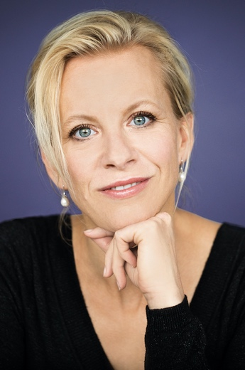
Among plans of Astrid Kessler are an operatic gala concert in Ludwigsburg, as well as Sieglinde in Die Walküre in Dortmund. She will give her debut in the role of Chrysothemis in a new production of Elektra.

Lately she sang Alice Ford in Falstaff in Stuttgart, the title role of Richard Strauss’ Salome at Volksoper Vienna, Eva in Die Meistersinger von Nürnberg in Leipzig, Anna in concert performances of Puccini’s Le Villi with Oper Mannheim, Elsa in Lohengrin in Dortmund, Elisabeth in a new production Tannhäuser in Essen conducted by Tomáš Netopil, Rosalinde in Die Fledermaus in Düsseldorf, Stuttgart and in Tokyo, Sieglinde in Dortmund and a concert performance of Lohengrin at the Ludwigsburg Festival.

Astrid Kessler took over on short notice the title role of Arabella 2023 in Madrid, a role which she sung also in the new production of Zurich Opera directed by Robert Carsen and conducted by Fabio Luisi in March 2020. She gave her debut in the part only a few weeks earlier in Leipzig conducted by ulf Schirmer.

In Mannheim she performed Madame Butterfly, Sieglinde in Loriot‘s Der Ring an einem Abend, Marschallin in Der Rosenkavalier, Desdemona in Otello, Mélisande in Pelléas et Mélisande, Ellen Orford in a new production Peter Grimes and a new production of Phantome der Oper.

2019 Astrid Kessler was highly successful in the part of Sieglinde in Die Walküre at Ludwigsburg Festival next to Klaus Florian Vogt and Catherine Foster and in the same part in Chemnitz. In Mannheim she was heard as Eva in Die Meistersinger von Nürnberg and as Mélisande in Pelléas et Mélisande, in Saarbrücken she performed Abigail in Nabucco. For the turn of the year 2018/19 she took over on short notice the part of Rosalinde in semi-staged performances Die Fledermaus at Hamburg Elbphilharmonie conducted by Manfred Honeck.
2017 Astrid Kessler guested at Deutsche Oper am Rhein in Düsseldorf in Franz Lehar’s operetta Der Graf von Luxemburg as Angèle Didier. She gave her debuts in the title role of Alfredo Catalani’s La Wally conducted by Marc Piollet at Vienna Volksoper, as Feldmarschallin in Der Rosenkavalier and as Elisabeth in Tannhäuser in Mannheim.

Since 2012 she belongs to the ensemble of Mannheim National Theatre, where she has sung almost all suitable roles of her fach like Agathe in Der Freischütz, Cio-Cio-San in Madame Butterfly, Liú in Turandot, Nedda in I Pagliacci, Contessa in Le Nozze di Figaro, Rosalinde in Die Fledermaus, Hanna Glawari in Die lustige Witwe, Alice Ford in Falstaff, Mimì in La Bohème, Micaela in Carmen, Governess in Benjamin Brittens The Turn of the Screw, Rachel in Halevy’s La Juive directed by Peter Konwitschny.

2014 at Vienna Volksoper Astrid Kessler gave her highly acclaimed debut in Emmerich Kálmán’s Gräfin Mariza and guested as Donna Elvira in Mozart’s Don Giovanni at Deutschen Oper am Rhein in both Düsseldorf and Duisburg.
Astrid Kessler was heard at the Teatro Real Madrid, in the title role of Verdi’s Giovanna d´Arco Theater Bielefeld and as Sonja in Franz Léhar’s operetta Der Zarewitsch at Staatsoperette Dresden.
She gave her operatic debut 2011 at Theater Osnabrück in the roles of Donna Elvira und Angèle Didier.

She began her vocal education at the age of 16 at the international School in Seoul. After a class of acting at the Oswego State University in New York, USA, she studied voice at the Hochschule für Musik in Nuremburg with Prof. Elisabeth Kovacs and continued her studies with Prof. Reiner Goldberg in Berlin and with Prof. Peter Anton Ling in Hannover.

12/2023

